Title in English: Capitalize All Words Except for Articles, Conjunctions, and Prepositions Fewer Than Four Letters

SURNAME, Name
Name of Affiliation in English

SURNAME, Name
Name of Affiliation in English

Abstract
Provide an abstract of no more than 200 words. Provide an abstract of no more than 200 words. Provide an abstract of no more than 200 words. Provide an abstract of no more than 200 words. Provide an abstract of no more than 200 words. Provide an abstract of no more than 200 words. Provide an abstract of no more than 200 words. Provide an abstract of no more than 200 words. Provide an abstract of no more than 200 words. Provide an abstract of no more than 200 words. Provide an abstract of no more than 200 words. Provide an abstract of no more than 200 words. Provide an abstract of no more than 200 words. Provide an abstract of no more than 200 words. Provide an abstract of no more than 200 words. Provide an abstract of no more than 200 words. Provide an abstract of no more than 200 words. Provide an abstract of no more than 200 words. Provide an abstract of no more than 200 words. Provide an abstract of no more than 200 words. Provide an abstract of no more than 200 words. Provide an abstract of no more than 200 words.

Keywords: keyword 1, keyword 2, keyword 3, keyword 4, keyword 5

1. Introduction
This is a template for authors who wish to write a manuscript for submission to LET Kanto Journal. Use this template while referring to the “Toukou-Kitei” for LET Kanto Journal (Rules for manuscript submission written in Japanese). The writing style of the manuscript should follow this template and the latest edition of the Publication Manual of the American Psychological Association (APA). Do not change the typefaces and font sizes shown in this template (basic settings: Times New Roman, 12pt). Papers should not exceed 30 pages including tables, figures, and references.

2. Manuscript Preparation Guidelines
2.1 The Title Page
The title should be centered on the page and set in boldface (font size 14pt). The author’s name should follow the title and be justified to the right (font size 12pt). Authors should provide an abstract of no more than 200 words and a list of three to five keywords.

2.2 Section Headings
LET Kanto Journal uses three levels for headings. Sections should be numbered with Arabic numerals. Second-level sections should be numbered 1.1, 1.2, 1.3, etc.; third-level sections should be numbered 1.1.1, 1.1.2, 1.1.3, etc. In the first- and second-level headings, the first letter of each word should be capitalized, and in the third-level headings, the first letter of the first word should be capitalized. Table 1 shows the format.

Table 1
Format for Three Levels of Heading in LET Kanto Journal
Level of heading | Format (example) | Note
1 | 3. The Study | period, upper case
2 | 3.1 Purpose | no period, upper case
3 | 3.2.1 Classroom context and activity | no period, lower case except the first word

Sections should be separated by one blank line except when the section ends with a table or a figure.

2.3 Citing References in the Text
References should be cited in the text by the author’s surname and the date of publication in brackets, for example (Taylor & Gisaki, 2003). All references cited in the text should be included in the reference list at the end of the paper.

2.4 Tables
Refer to Table 1 shown in section 2.1 in this template. Tables should be numbered with Arabic numerals, and they should be cited in the text in numerical order. Titles in italics should be placed directly above the table.

2.5 Figures
Figures should also be numbered consecutively with Arabic numerals and should be cited in the text in numerical order. Figure 1 is an example. The caption for a figure should appear below the figure, and the word ‘Figure’ and the associated number should be italicized (i.e., Figure 1). The title of the figure is typed in sentence case.

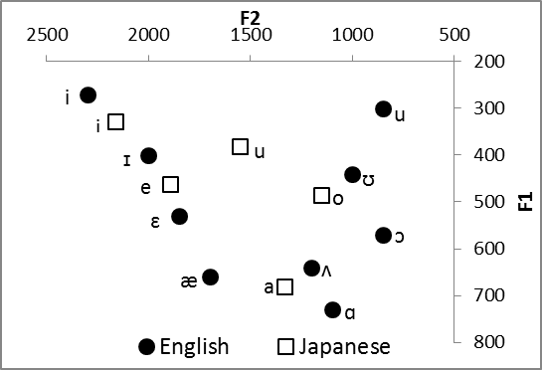

Figure 1. This figure shows F1 and F2 frequencies
of English and Japanese vowels.

3. Conclusion
This template covers manuscript preparation for LET Kanto Journal. Authors who wish to write a manuscript for submission to the journal are required to use this template.

Notes
1. Do not use footnotes but endnotes. Endnote numbers should be superscripted like this¹ consecutively in the text.

References
References should be ordered alphabetically. All sources cited in the text should be listed in the references. An example of references is given below. Note that an en dash (–) is used instead of a hyphen (-) or an em dash (―).

Arakawa, M., Ueki, Y., & Fuyuki, M. (2004). A spontaneous learning activation spiral education method utilizing Web-based coordinated education activation system CEAS. Japan Journal of Educational Technology, 28, 311–321.
Bax, S. (2003). CALL: Past, present and future. System, 31, 13–28.
Corbin, J., & Strauss, A. (2008). Basics of qualitative research: Techniques and procedures for developing grounded theory (3rd ed.). London: Sage.
Dörnyei, Z. (2007). Research methods in applied linguistics: Quantitative, qualitative, and mixed methodologies. Oxford: Oxford University Press.
Szabo, M., & Flesher, K. (2002). CMI theory and practice: Historical roots of learning management systems. In G. Richards (Ed.), Proceedings of world conference on e-learning in corporate, government, healthcare, and higher education 2002 (pp. 929–936). Chesapeake, VA: AACE.
Thornton, P., & Sharples, M. (2005). Patterns of technology use in self-directed Japanese language learning projects and implications for new mobile support tools. Paper presented at the Proceedings of the 2005 IEEE International Workshop on Wireless and Mobile Technologies in Education.
Warschauer, M. (1998). CALL vs. electronic literacy: Reconceiving technology in the language classroom. Retrieved from http://www.cilt.org.uk/research/papers /resfor2/warsum1.htm
Warschauer, M. (2005). Sociocultural perspectives on CALL. In J. L. Egbert & G. M. Petrie (Eds.), CALL research perspectives (pp. 41–51). Mahwah, NJ: Lawrence Erlbaum Associates.

