Title in English: Capitalize All Words Except for Articles, Conjunctions, and Prepositions Fewer Than Four Letters

SURNAME, Name
Name of Affiliation in English

Abstract
Articles should have an abstract up to 200 words in English. Articles should have an abstract up to 200 words in English. Articles should have an abstract up to 200 words in English. Articles should have an abstract up to 200 words in English. Articles should have an abstract up to 200 words in English. Articles should have an abstract up to 200 words in English. Articles should have an abstract up to 200 words in English. Articles should have an abstract up to 200 words in English. Articles should have an abstract up to 200 words in English. Articles should have an abstract up to 200 words in English. Articles should have an abstract up to 200 words in English. Articles should have an abstract up to 200 words in English. Articles should have an abstract up to 200 words in English. Articles should have an abstract up to 200 words in English. Articles should have an abstract up to 200 words in English. Articles should have an abstract up to 200 words in English. Articles should have an abstract up to 200 words in English. Articles should have an abstract up to 200 words in English.

Keywords: keyword 1, keyword 2, keyword 3, keyword 4, keyword 5

1. Introduction
This is a template for authors who wish to submit a manuscript to Language Education & Technology (LET). Manuscripts written in English should follow this template regardless of whether they are research articles or practice reports; on the first page, delete either “Research Article” or “Practice Report” in the header to make the category clear. When there are multiple authors, leave one blank line after the first author before entering the next name and affiliation. Every manuscript, whatever the language of the main text, must carry an abstract of up to 200 words in English, followed by up to five keywords. Use this template together with the latest edition of the Publication Manual of the American Psychological Association (7th ed., 2020).
1.1 Writing the Title
In an English title, capitalize the first letter of every word except articles and conjunctions or prepositions of fewer than four letters; separate a subtitle with a colon. In a Japanese title, enclose the subtitle between dashes (―). Center the title and set it in 14-point bold type.

1.2 Writing the Affiliation
State the affiliation exactly as registered with LET (this also applies to in-service teachers who are graduate students). If you wish to use a different affiliation, first update it on the society website. Do not list more than one affiliation, and do not add notes such as “part-time.” For graduate students, write “Graduate Student, ** University,” without distinguishing master’s from doctoral programs.

1.3 Formatting Notes
Do not change the typefaces, font sizes, margins, section-numbering, or indentation defined in this template. When you paste text prepared in a separate file, take care that its formatting is not carried over. Use Times (New Roman) for English text at 12 points, with 35 lines per page. Manuscripts should not exceed 30 pages including tables, figures, and references. Use an en dash (–) for page and number ranges. Page numbers may be inserted, but must be removed from the final accepted manuscript.

1.4 Section Numbering (Levels of Heading)
LET uses up to three levels of heading. A period follows the top-level number (e.g., “1. Introduction”); no period follows lower levels (e.g., “1.3 Formatting Notes”; “1.3.1 Classroom context”). At level 1, capitalize the first letter of each major word; at level 3, capitalize only the first word. Insert two half-width spaces (one full-width space) after each number. Leave one blank line before a new heading, and two blank lines when a table or figure ends a section.

2. Other Guidelines
2.1 Citing References in the Text
References are cited in the text with an author–date system and listed alphabetically in the reference list. The following paragraph is an example.
With the innovation and diffusion of information communication technology (ICT), the traditional CALL lab is no longer the only place where students meet authentic resources for language learning (Taylor & Gisaki, 2003). Students now use new technology outside the classroom rather than inside (Warschauer, 2005). Warschauer (1998) thus called for a reformulation of CALL. Kern (2006) likewise argued for broadening the potential relationships between technology and language learning. Lafford (2009), for example, stressed the importance of integrating technology into teaching practices in a given local context (p. 676). As a result, CALL has moved from simple comparative research toward more integrative studies of technology and pedagogy in local contexts (Garrett, 2009).
(APA 7th change) For works with three or more authors, use “first author et al.” from the very first citation (the 6th-edition rule of spelling out all authors for three to five names on the first citation is discontinued).

2.2 Tables
Place each table in the text and number it consecutively with Arabic numerals. In APA 7th edition, put the table number (bold) above the table and the table title (italic, title case) on the next line. Use horizontal rules only—at the top and bottom of the table and beneath the column headings—never vertical rules. Keep numerals and text large enough to remain legible after reduction. Leave two blank lines when a table ends a section.

Table 1
Results of the Tests and Their Analysis
Test | Group Aª | Group Bª | Group Cª | F | p
Listening | 59.13 (9.76) | 57.21 (7.61) | 53.77 (7.46) | 4.39 | .02
Speaking | 64.33 (14.54) | 57.17 (13.61) | 53.61 (19.81) | 4.53 | .01
Note. ªn = 40; Mean (SD)

2.3 Figures
Number figures consecutively with Arabic numerals. In APA 7th edition, the figure number (bold) and the figure title (italic, title case) appear above the figure—not below it as in the 6th edition. Because figures are printed in black and white, do not use color, including for chart backgrounds. Keep axis labels and numbers legible after reduction. If you reproduce a figure from another source, confirm whether permission is required and, if so, obtain it before submission. Leave two blank lines when a figure ends a section.
Figure 1
A Schematic Representation of the Simulation
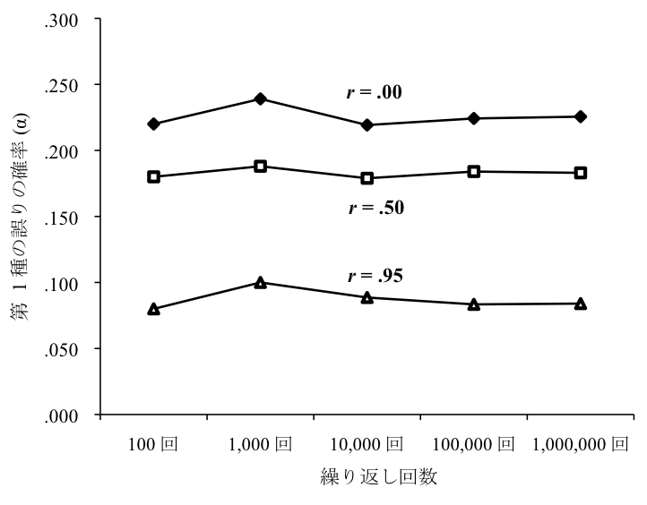

2.4 Terms
2.4.1 Ethical Considerations (Reduction of Bias)
Where possible, replace “experimental group” and “control group” with “treatment group” and “contrast group.” The term “participants” is generally preferable to “subjects.” For further guidance on reducing bias, see APA 7th edition, Chapter 5 (Bias-Free Language Guidelines), and the submission checklist.

2.4.2 Ensuring Anonymity
To facilitate blind review, remove the author’s name from the main text, in-text citations, reference list, and any running heads. Replace it with “Author” (or “Author 1,” “Author 2,” and so on for multiple authors); this does not apply to the names below the title on the first page. Place your own cited works at the end of the reference list as “Author.” When the paper is accepted, restore the correct information in the final manuscript. Manuscripts submitted without the author’s name(s) removed will be returned for revision and resubmission.

Acknowledgements
If there are acknowledgements, place them immediately after the main text. Do not include individual names at submission; keep them anonymous, for example: The authors would like to thank XXX for advice on an earlier version of this manuscript.

Notes
1. Use endnotes rather than footnotes. Endnotes are gathered between the main text and the reference list, not at the foot of each page.
2. In the main text, mark notes with a superscript numeral, like this,¹ numbered consecutively.

References
Campbell, D. T., & Kenny, D. A. (1999). A primer on regression artifacts. Guilford Press.
Cohen, J. (1988). Statistical power analysis for the behavioral sciences (2nd ed.). Lawrence Erlbaum.
Haybron, D. M. (2008). Philosophy and the science of subjective well-being. In M. Eid & R. J. Larsen (Eds.), The science of subjective well-being (pp. 17–43). Guilford Press.
In’nami, Y., & Koizumi, R. (2009). A meta-analysis of test format effects on reading and listening test performance: Focus on multiple-choice and open-ended formats. Language Testing, 26(2), 219–244.
Kalnay, E., Kanamitsu, M., Kistler, R., Collins, W., Deaven, D., Gandin, L., Iredell, M., Saha, S., White, G., Woollen, J., Zhu, Y., Chelliah, M., Ebisuzaki, W., Higgins, W., Janowiak, J., Mo, K. C., Ropelewski, C., Wang, J., Leetmaa, A., . . . Joseph, D. (1996). The NCEP/NCAR 40-year reanalysis project. Bulletin of the American Meteorological Society, 77(3), 437–471. https://doi.org/10.1175/1520-0477(1996)077<0437:TNYRP>2.0.CO;2
Morey, C. C., Cong, Y., Zheng, Y., Price, M., & Morey, R. D. (2015). The color-sharing bonus: Roles of perceptual organization and attentive processes in visual working memory. Archives of Scientific Psychology, 3, 18–29. https://doi.org/10.1037/arc0000014
Sillick, T. J., & Schutte, N. S. (2006). Emotional intelligence and self-esteem mediate between perceived early parental love and adult happiness. E-Journal of Applied Psychology, 2, 38–48. http://ojs.lib.swin.edu.au/index.php/ejap
Author. (2010).

- List only works cited in the text, in alphabetical order.
- Do not include the publisher’s location (city or state).
- Add the issue number in parentheses after the volume when the journal uses issue numbers, e.g., 26(2); give the volume only for journals without issue numbers.
- Provide the DOI when one exists, formatted as https://doi.org/… (do not use “doi:” or “Retrieved from”). See https://apastyle.apa.org/style-grammar-guidelines/references/dois-urls.
- For online works without a DOI, give the URL (a retrieval date is normally unnecessary).
- List up to 20 authors; for 21 or more, give the first 19, an ellipsis (…), and the final author.
- Use an en dash (–) for page ranges, not a hyphen.
- To preserve anonymity, place your own cited works at the end of the list as “Author” (submission only).

© LET 2026 All rights reserved. Not for commercial use or unauthorized distribution.

